Chapter 5: Enzymes
Enzymes are crucial biological molecules that facilitate and regulate biochemical reactions within living organisms. They are essential for processes ranging from digestion to DNA replication.

5.1 Enzymes

What are Enzymes?
- A catalyst is a substance that increases the rate of a chemical reaction without being consumed or permanently changed in the process.
- Enzymes are biological catalysts. They are proteins that are involved in all metabolic reactions within living cells, where they function to speed up these reactions.

Importance of Enzymes
Enzymes are vital for all living organisms because they enable biochemical reactions to occur at a rate necessary to sustain life. Without enzymes, most metabolic reactions would proceed too slowly at body temperature to support life processes.

Enzyme Action: The Lock and Key / Induced Fit Model
Enzymes function by binding to specific molecules called substrates. The region on the enzyme where the substrate binds is known as the active site.
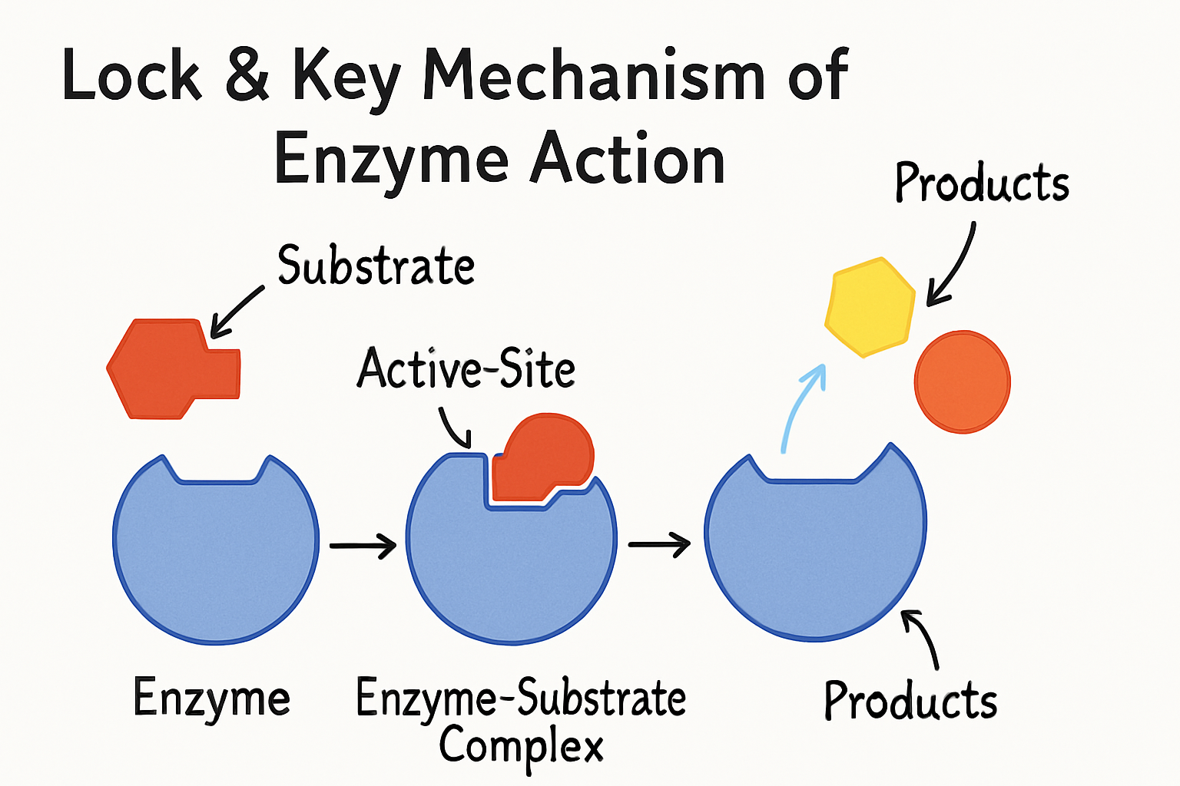
- Active Site: The active site is a specific three-dimensional shape on the enzyme molecule that is complementary to the shape of its specific substrate. This complementary is often described by the lock and key model, where the substrate (key) fits perfectly into the active site (lock).
- Enzyme-Substrate Complex: When the substrate binds to the active site, an enzyme-substrate complex is formed. This binding is temporary and reversible.
- Catalysis: Within the enzyme-substrate complex, the enzyme facilitates the chemical reaction, converting the substrate into one or more products.
- Product Release: Once the reaction is complete, the products are released from the active site, and the enzyme is free to bind to another substrate molecule and catalyze the reaction again.

Specificity of Enzymes
Enzymes are highly specific in their action. Each enzyme typically catalyzes only one or a very small number of specific reactions. This specificity is due to the unique complementary shape and fit of the active site with its particular substrate. Just as a specific key fits only one lock, a specific enzyme's active site will only bind to its specific substrate.

Factors Affecting Enzyme Activity
The activity of enzymes is highly sensitive to changes in their environment, particularly temperature and pH.

Effect of Temperature
- Low Temperatures: At low temperatures, enzyme activity is low because the kinetic energy of enzyme and substrate molecules is reduced. This leads to fewer collisions between the enzyme's active site and the substrate, thus fewer enzyme-substrate complexes are formed.
- Optimum Temperature: As temperature increases, the kinetic energy of molecules increases, leading to more frequent and energetic collisions between enzyme and substrate, thus more enzyme-substrate complexes are formed. This increases the rate of enzyme activity up to an optimum temperature. For most human enzymes, the optimum temperature is around 37°C.
- High Temperatures (Denaturation): Beyond the optimum temperature, the enzyme's structure begins to break down. The increased kinetic energy causes vibrations that break the weak bonds holding the enzyme's specific three-dimensional shape, particularly the active site. This irreversible change in shape is called denaturation. A denatured enzyme loses its complementary shape to the substrate (substrate no longer fits), and thus its ability to catalyze reactions, leading to a rapid decrease in enzyme activity.

Effect of pH
- Optimum pH: Each enzyme has an optimum pH at which it exhibits maximum activity. Deviations from this optimum pH can affect the enzyme's structure and function.
- Changes in pH (Denaturation): Extreme changes in pH (either too acidic or too alkaline) can alter the charges on the amino acids that make up the enzyme, disrupting the bonds that maintain the active site's specific three-dimensional shape. This leads to denaturation, where the active site changes shape, and the enzyme can no longer bind effectively to its substrate, resulting in a loss of activity.
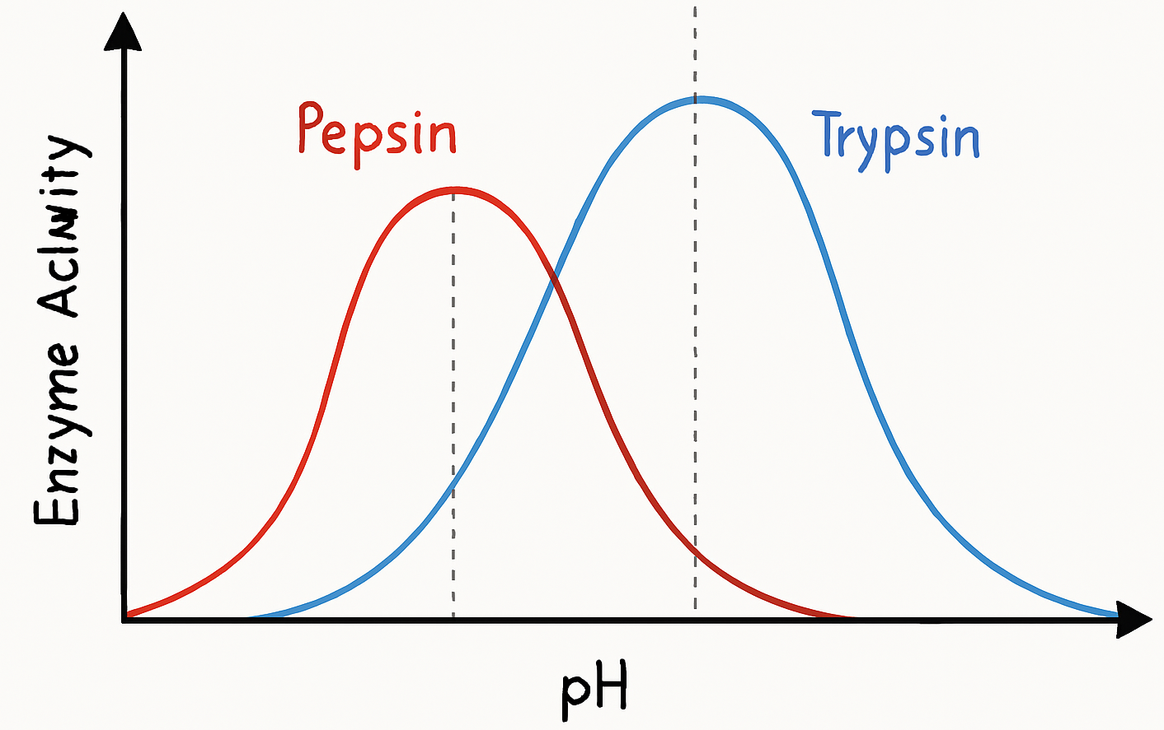
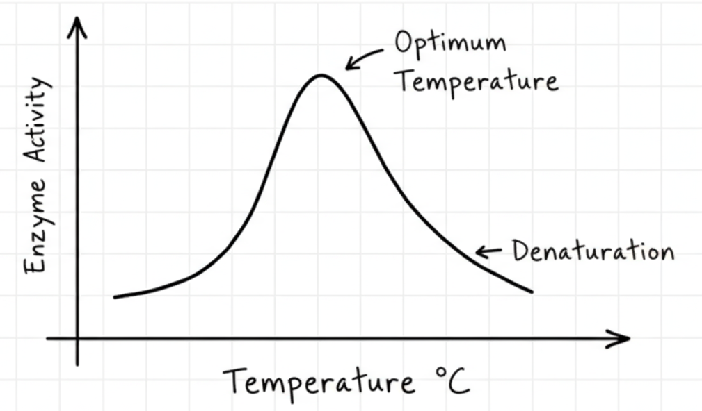
  - For example, pepsin, an enzyme in the stomach, has an optimum pH of around 2 (acidic), while trypsin, an enzyme in the small intestine, has an optimum pH of around 8 (alkaline).

